Quantifiers Determiners

🔹 What Are Quantifiers (Types of Determiners)?
# Source: AI Source: Provided by: [Data Path: Persons Table -> ID Column: 1, Name_En Column: Motasem Essam] -> From: [Chatgpt (GPT-4-turbo)] on [7/28/2025]
Quantifiers are determiners that indicate quantity or amount — how much or how many.
They are used before nouns and help answer questions like:
How many? or How much?

✅ Examples of Common Quantifiers:
# Source: AI Source: Provided by: [Data Path: Persons Table -> ID Column: 1, Name_En Column: Motasem Essam] -> From: [Chatgpt (GPT-4-turbo)] on [7/28/2025]
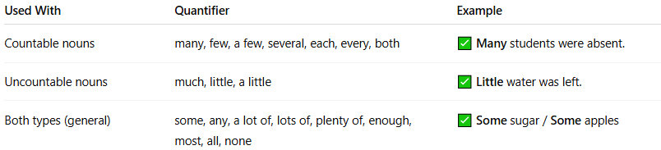
Used With | Quantifier | Example
Countable nouns | many, few, a few, several, each, every, both | ✅ Many students were absent.
Uncountable nouns | much, little, a little | ✅ Little water was left.
Both types (general) | some, any, a lot of, lots of, plenty of, enough, most, all, none | ✅ Some sugar / Some apples

📚 Categorizing Quantifiers:

1. For Countable Nouns
# Source: AI Source: Provided by: [Data Path: Persons Table -> ID Column: 1, Name_En Column: Motasem Essam] -> From: [Chatgpt (GPT-4-turbo)] on [7/28/2025]
- many, few, a few, several, each, every, both, fewer, number of
🧾 Example: Few people came to the event.

2. For Uncountable Nouns
# Source: AI Source: Provided by: [Data Path: Persons Table -> ID Column: 1, Name_En Column: Motasem Essam] -> From: [Chatgpt (GPT-4-turbo)] on [7/28/2025]
- much, little, a little, less, amount of
🧾 Example: There's little hope.

3. Used with Both
# Source: AI Source: Provided by: [Data Path: Persons Table -> ID Column: 1, Name_En Column: Motasem Essam] -> From: [Chatgpt (GPT-4-turbo)] on [7/28/2025]
- some, any, a lot of, lots of, all, plenty of, enough, no, most, none
🧾 Example:
Some rice (uncountable)
Some books (countable)

🧩 Notes:
# Source: AI Source: Provided by: [Data Path: Persons Table -> ID Column: 1, Name_En Column: Motasem Essam] -> From: [Chatgpt (GPT-4-turbo)] on [7/28/2025]
- Quantifiers come before the noun (and before adjectives if present).
- They do not specify the exact number but give a general sense of quantity.

✅ Example Sentences:
# Source: AI Source: Provided by: [Data Path: Persons Table -> ID Column: 1, Name_En Column: Motasem Essam] -> From: [Chatgpt (GPT-4-turbo)] on [7/28/2025]
- Many dogs barked.
- I have a little time.
- She drank some milk.
- All students must attend.
- We saw few birds.

